import pandas as pd import seaborn as sns

import matplotlib.pyplot as plt import numpy as np

sns.set_style('darkgrid') sns.set(font_scale=1.3)

df=pd.read_csv("/content/drive/MyDrive/IBM/Assignment - 2 /Churn_Modelling.csv")

df.head()



|  |  |  |  |  |  |  |  |  |
| --- | --- | --- | --- | --- | --- | --- | --- | --- |
| **RowNumber** | **CustomerId** | **Surname** | **CreditScore** | **Geography** | **Gender** | **Age** | **Tenure** | **Balan** |
| **0** 1 | 15634602 | Hargrave | 619 | France | Female | 42 | 2 | 0. |
| **1** 2 | 15647311 | Hill | 608 | Spain | Female | 41 | 1 | 83807. |
| **2** 3 | 15619304 | Onio | 502 | France | Female | 42 | 8 | 159660. |
| **3** 4 | 15701354 | Boni | 699 | France | Female | 39 | 1 | 0. |
| **4** 5 | 15737888 | Mitchell | 850 | Spain | Female | 43 | 2 | 125510. |

df.drop(["RowNumber","CustomerId","Surname"],axis=1,inplace=True)

df.info()

<class 'pandas.core.frame.DataFrame'> RangeIndex: 10000 entries, 0 to 9999 Data columns (total 11 columns):

# Column Non-Null Count Dtype

1. CreditScore 10000 non-null int64
2. Geography 10000 non-null object
3. Gender 10000 non-null object
4. Age 10000 non-null int64
5. Tenure 10000 non-null int64
6. Balance 10000 non-null float64
7. NumOfProducts 10000 non-null int64
8. HasCrCard 10000 non-null int64
9. IsActiveMember 10000 non-null int64
10. EstimatedSalary 10000 non-null float64
11. Exited 10000 non-null int64 dtypes: float64(2), int64(7), object(2)

memory usage: 859.5+ KB

#Perform Univariate Analysis plt.figure(figsize=(8,8))

sns.countplot(x='Tenure',data=df)

plt.xlabel('0:Customers with Bank, 1: exited from bank') plt.ylabel('No.of.Customers')

plt.title("Bank Customers viz") plt.show()

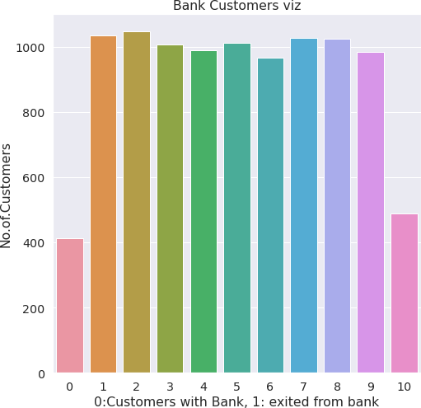

#Perform Univariate Analysis plt.figure(figsize=(8,8))

sns.kdeplot(x=df['Balance'])

<matplotlib.axes._subplots.AxesSubplot at 0x7fa0c03906d0>

#Perform Bivariate Analysis

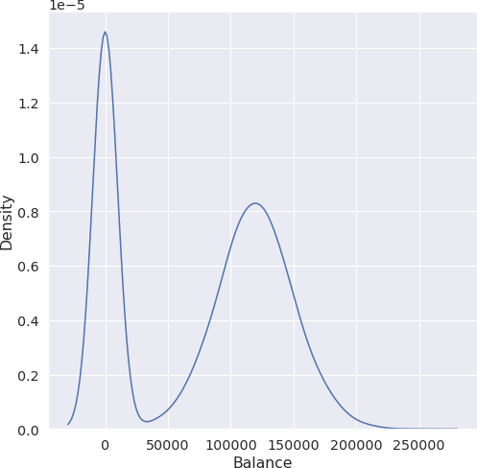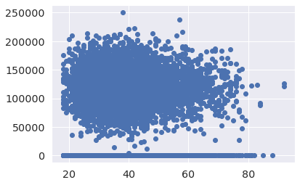

plt.scatter(df.Age,df.Balance)

<matplotlib.collections.PathCollection at 0x7fa0d35a7dd0>

#Perform Bivariate Analysis df.corr()

|  |  |  |  |  |  |  |
| --- | --- | --- | --- | --- | --- | --- |
|  | **CreditScore** | **Gender** | **Age** | **Tenure** | **Balance** | **NumOfProduc** |
| **CreditScore** | 1.000000 | 0.007888 | -0.003965 | 0.000842 | 0.006268 | 0.0122 |
| **Gender** | 0.007888 | 1.000000 | 0.022812 | 0.003739 | 0.069408 | 0.0039 |
| **Age** | -0.003965 | 0.022812 | 1.000000 | -0.009997 | 0.028308 | -0.0306 |
| **Tenure** | 0.000842 | 0.003739 | -0.009997 | 1.000000 | -0.012254 | 0.0134 |
| **Balance** | 0.006268 | 0.069408 | 0.028308 | -0.012254 | 1.000000 | -0.3041 |
| #Perform Bivariate | Analysis |  |  |  |  |  |

import statsmodels.api as sm

**NumOfProducts** 0.012238 0.003972 -0.030680 0.013444 -0.304180 1.0000

**HasCrCard** -0.005458 -0.008523 -0.011721 0.022583 -0.014858 0.0031

**IsActiveMember** 0.025651 0.006724 0.085472 -0.028362 -0.010084 0.0096

**EstimatedSalary** -0.001384 -0.001369 -0.007201 0.007784 0.012797 0.0142

**Exited** -0.027094 0.035943 0.285323 -0.014001 0.118533 -0.0478

#define response variable y = df['CreditScore']

#define explanatory variable x = df[['EstimatedSalary']]

#add constant to predictor variables x = sm.add_constant(x)

#fit linear regression model model = sm.OLS(y, x).fit()

#view model summary

print(model.summary())

OLS Regression Results

==============================================================================

|  |  |  |  |  |  |  |  |
| --- | --- | --- | --- | --- | --- | --- | --- |
| Dep. Variable: | | CreditScore | | R-squared: | | 0.000 | |
| Model: | | OLS | | Adj. R-squared: | | -0.000 | |
| Method: | | Least Squares | | F-statistic: | | 0.01916 | |
| Date: | | Sat, 24 Sep 2022 | | Prob (F-statistic): | | 0.890 | |
| Time: | | 05:06:19 | | Log-Likelihood: | | -59900. | |
| No. Observations: | | 10000 | | AIC: | | 1.198e+05 | |
| Df Residuals: | | 9998 | | BIC: | | 1.198e+05 | |
| Df Model: | | 1 | |  | |  | |
| Covariance Type: | | nonrobust | |  | |  | |
| ===================================================================================  coef std err t P>|t| [0.025 0.975] | | | | | | | |
| const | 650.7617 | | 1.940 | 335.407 | 0.000 | 646.958 | 654.565 |
| EstimatedSalary | -2.326e-06 | | 1.68e-05 | -0.138 | 0.890 | -3.53e-05 | 3.06e-05 |
| ==============================================================================  Omnibus: 132.939 Durbin-Watson: 2.014 | | | | | | | |
| Prob(Omnibus): | 0.000 | | | Jarque-Bera (JB): | | 84.242 | |
| Skew: | -0.072 | | | Prob(JB): | | 5.10e-19 | |
| Kurtosis: | 2.574 | | | Cond. No. | | 2.32e+05 | |

==============================================================================

Notes:

1. Standard Errors assume that the covariance matrix of the errors is correctly specif
2. The condition number is large, 2.32e+05. This might indicate that there are strong multicollinearity or other numerical problems.

/usr/local/lib/python3.7/dist-packages/statsmodels/tsa/tsatools.py:142: FutureWarning: x = pd.concat(x[::order], 1)

#Perform Multivariate Analysis plt.figure(figsize=(4,4))

sns.pairplot(data=df[["Balance","CreditScore","EstimatedSalary","NumOfProducts","Tenure","Exi

<seaborn.axisgrid.PairGrid at 0x7fa0b00a1b10>

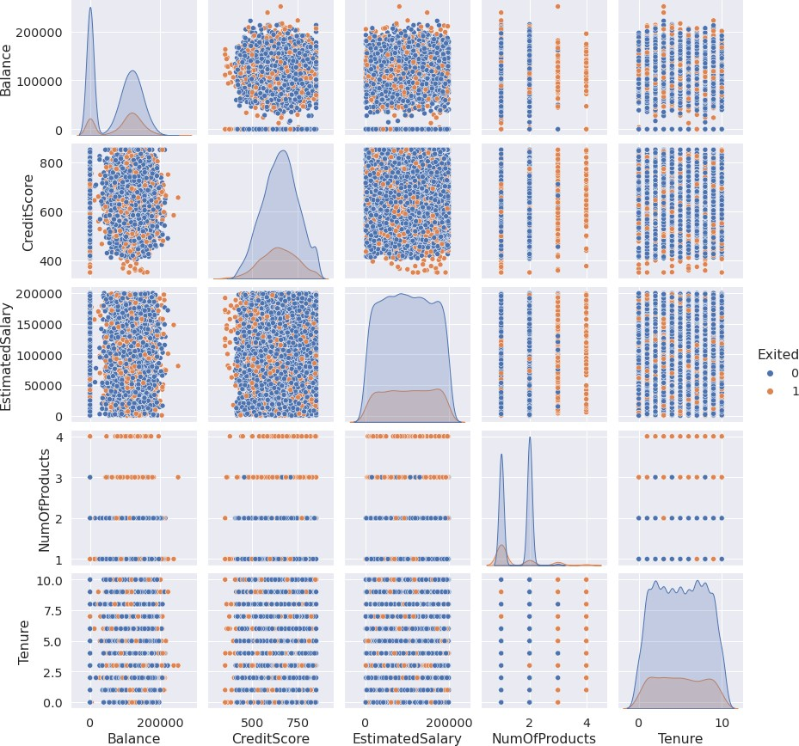

<Figure size 288x288 with 0 Axes>

#Perform Descriptive Statistics df=pd.DataFrame(df)

print(df.sum())

|  |  |
| --- | --- |
| CreditScore  Geography Gender | 6505288  FranceSpainFranceFranceSpainSpainFranceGermany... FemaleFemaleFemaleFemaleFemaleMaleMaleFemaleMa... |
| Age | 389218 |
| Tenure | 50128 |
| Balance | 764858892.88 |
| NumOfProducts | 15302 |
| HasCrCard | 7055 |
| IsActiveMember | 5151 |
| EstimatedSalary | 1000902398.81 |
| Exited  dtype: object | 2037 |

#Perform Descriptive Statistics print("----Sum Value ")

print(df.sum(1))

print(" ")

print("-----Product Value ")

print(df.prod())

print(" ")

|  |  |  |
| --- | --- | --- |
| ----Sum | Value----- | |
| 0 | 102015.88 | |
| 1 | 197002.44 | |
| 2 | 274149.37 | |
| 3 | 94567.63 | |
| 4  9995 | 205492.92  ...  97088.64 | |
| 9996 | 159633.38 | |
| 9997 | 42840.58 | |
| 9998 | 168784.83 | |
| 9999 | 169159.57 | |
| Length: | 10000, dtype: float64 | |
| -----Product | | Value----- |
| CreditScore | | 0.0 |
| Age | | 0.0 |
| Tenure | | 0.0 |
| Balance | | 0.0 |
| NumOfProducts | | 0.0 |

HasCrCard 0.0

IsActiveMember 0.0

EstimatedSalary inf Exited 0.0

dtype: float64

/usr/local/lib/python3.7/dist-packages/ipykernel_launcher.py:3: FutureWarning: Dropping This is separate from the ipykernel package so we can avoid doing imports until

/usr/local/lib/python3.7/dist-packages/numpy/core/_methods.py:52: RuntimeWarning: overf

return umr_prod(a, axis, dtype, out, keepdims, initial, where)

/usr/local/lib/python3.7/dist-packages/ipykernel_launcher.py:6: FutureWarning: Dropping

#Perform Descriptive Statistics

print("----------Mean Value ")

print(df.mean())

print(" ")

print("----------Median Value ")

print(df.median())

print(" ")

print("----------Mode Value ")

print(df.mode())

print(" ")

|  |  |
| --- | --- |
| ----------Mean | Value----------- |
| CreditScore | 650.528800 |
| Age | 38.921800 |
| Tenure | 5.012800 |
| Balance | 76485.889288 |
| NumOfProducts | 1.530200 |
| HasCrCard | 0.705500 |
| IsActiveMember | 0.515100 |
| EstimatedSalary | 100090.239881 |
| Exited  dtype: float64 | 0.203700 |

|  |  |
| --- | --- |
| ----------Median | Value--------- |
| CreditScore | 652.000 |
| Age | 37.000 |
| Tenure | 5.000 |
| Balance | 97198.540 |
| NumOfProducts | 1.000 |
| HasCrCard | 1.000 |
| IsActiveMember | 1.000 |
| EstimatedSalary | 100193.915 |
| Exited  dtype: float64 | 0.000 |

----------Mode Value------------

CreditScore Geography Gender Age Tenure Balance NumOfProducts \ 0 850 France Male 37 2 0.0 1

HasCrCard IsActiveMember EstimatedSalary Exited

0 1 1 24924.92 0

/usr/local/lib/python3.7/dist-packages/ipykernel_launcher.py:3: FutureWarning: Dropping This is separate from the ipykernel package so we can avoid doing imports until

/usr/local/lib/python3.7/dist-packages/ipykernel_launcher.py:6: FutureWarning: Dropping

#Handling with missing Values

df.isnull()#Checking values are null

|  |  |  |  |  |  |  |  |  |
| --- | --- | --- | --- | --- | --- | --- | --- | --- |
|  | **CreditScore** | **Geography** | **Gender** | **Age** | **Tenure** | **Balance** | **NumOfProducts** | **HasCr** |
| **0** | False | False | False | False | False | False | False |  |
| **1** | False | False | False | False | False | False | False |  |
| **2** | False | False | False | False | False | False | False |  |
| **3** | False | False | False | False | False | False | False |  |
| **4** | False | False | False | False | False | False | False |  |
| **...** | ... | ... | ... | ... | ... | ... | ... |  |
| **9995** | False | False | False | False | False | False | False |  |
| **9996** | False | False | False | False | False | False | False |  |
| **9997** | False | False | False | False | False | False | False |  |
| **9998** | False | False | False | False | False | False | False |  |
| **9999** | False | False | False | False | False | False | False |  |

10000 rows × 11 columns

#Handling with missing Values

df.notnull()#Checking values are not null

**9997** True True True True True True True **9998** True True True True True True True **9999** True True True True True True True

10000 rows × 11 columns

|  |  |  |  |  |  |  |  |
| --- | --- | --- | --- | --- | --- | --- | --- |
|  | **CreditScore** | **Geography** | **Gender** | **Age** | **Tenure** | **Balance** | **NumOfProducts HasCrC** |
| **0** | True | True | True | True | True | True | True |
| **1** | True | True | True | True | True | True | True |
| **2** | True | True | True | True | True | True | True |
| **3** | True | True | True | True | True | True | True |
| **4** | True | True | True | True | True | True | True |
| **...** | ... | ... | ... | ... | ... | ... | ... |
| **9995** | True | True | True | True | True | True | True |
| **9996** | True | True | True | True | True | True | True |

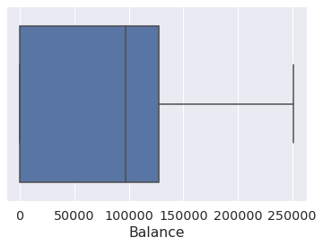

#Find outliers & replace the outliers sns.boxplot(df['Balance'])

/usr/local/lib/python3.7/dist-packages/seaborn/_decorators.py:43: FutureWarning: Pass t FutureWarning

<matplotlib.axes._subplots.AxesSubplot at 0x7fa0af6dcf90>

#Find outliers & replace the outliers print(np.where(df['Balance']>100000))

(array([ 2, 4, 5, ..., 9987, 9993, 9999]),)

#Find outliers & replace the outliers from scipy import stats

import numpy as np

z = np.abs(stats.zscore(df["EstimatedSalary"])) print(z)

0 0.021886

|  |  |
| --- | --- |
| 1 | 0.216534 |
| 2 | 0.240687 |
| 3 | 0.108918 |
| 4 | 0.365276  ... |
| 9995 | 0.066419 |
| 9996 | 0.027988 |
| 9997 | 1.008643 |
| 9998 | 0.125231 |
| 9999 | 1.076370 |
| Name: | EstimatedSalary, Length: 10000, dtype: float64 |
| #Check for | categorical columns & performs encoding |

from sklearn.preprocessing import LabelEncoder df['Gender'].unique()

array(['Female', 'Male'], dtype=object)

#Check for categorical columns & performs encoding df['Gender'].value_counts()

Male 5457

Female 4543

Name: Gender, dtype: int64

#Check for categorical columns & performs encoding encoding=LabelEncoder()

df["Gender"]=encoding.fit_transform(df.iloc[:,1].values) df

**CreditScore Geography Gender Age Tenure Balance NumOfProducts HasCr**

**0** 619 France 0 42 2 0.00 1

**1** 608 Spain 2 41 1 83807.86 1

#Check for categorical columns & performs encoding

**2** 502 France 0 42 8 159660.80 3

**3** 699 France 0 39 1 0.00 2

#Split the data into Dependent & Independent Variables print("----------Dependent Variables ")

**4** 850 Spain 2 43 2 125510.82 1

**...** ... ... ... ... ... ... ...

**9995** 771 France 0 39 5 0.00 2

**9996** 516 France 0 35 10 57369.61 1

**9997** 709 France 0 36 7 0.00 1

**9998** 772 Germany 1 42 3 75075.31 2

**9999** 792 France 0 28 4 130142.79 1

10000 rows × 11 columns

X=df.iloc[:,1:4] print(X)

print(" ")

print("---------Independent Variables ")

Y=df.iloc[:,4] print(Y)

print(" ")

----------Dependent Variables-----------

|  |  |  |  |
| --- | --- | --- | --- |
|  | Age | Tenure | Balance |
| 0 | 42 | 2 | 0.00 |
| 1 | 41 | 1 | 83807.86 |
| 2 | 42 | 8 | 159660.80 |
| 3 | 39 | 1 | 0.00 |
| 4 | 43 | 2 | 125510.82 |
| ... | ... | ... | ... |
| 9995 | 39 | 5 | 0.00 |
| 9996 | 35 | 10 | 57369.61 |
| 9997 | 36 | 7 | 0.00 |
| 9998 | 42 | 3 | 75075.31 |
| 9999 | 28 | 4 | 130142.79 |

[10000 rows x 3 columns]

---------Independent Variables---------

|  |  |  |
| --- | --- | --- |
| 0 | 1 |  |
| 1 | 1 |  |
| 2 | 3 |  |
| 3 | 2 |  |
| 4 | 1  .. |  |
| 9995 | 2 |  |
| 9996 | 1 |  |
| 9997 | 1 |  |
| 9998 | 2 |  |
| 9999  Name: | 1  NumOfProducts, Length: 10000, dtype: | int64 |

#Scale the independent Variables

from sklearn.preprocessing import StandardScaler object= StandardScaler()

# standardization

scale = object.fit_transform(df) print(scale)

[[-0.32622142 0.29351742 -1.04175968 ... 0.97024255 0.02188649

1.97716468]

[-0.44003595 0.19816383 -1.38753759 ... 0.97024255 0.21653375

-0.50577476]

[-1.53679418 0.29351742 1.03290776 ... -1.03067011 0.2406869

1.97716468]

...

|  |  |  |  |
| --- | --- | --- | --- |
| [ | 0.60498839 -0.27860412 | 0.68712986 ... 0.97024255 | -1.00864308 |
|  | 1.97716468] |  |  |
| [ | 1.25683526 0.29351742 | -0.69598177 ... -1.03067011 | -0.12523071 |
|  | 1.97716468] |  |  |
| [ | 1.46377078 -1.04143285 | -0.35020386 ... -1.03067011 | -1.07636976 |

-0.50577476]]

#Split the data into training & testing

from sklearn.model_selection import train_test_split

#Split the data into training & testing

x_train, x_test, y_train, y_test = train_test_split(x, y, test_size=4,random_state=4) x_train

|  |  |  |
| --- | --- | --- |
|  | **const** | **EstimatedSalary** |
| **2558** | 1.0 | 137903.54 |
| **7642** | 1.0 | 121765.00 |
| **8912** | 1.0 | 109470.34 |
| **3319** | 1.0 | 2923.61 |
| **6852** | 1.0 | 7312.25 |
| **...** | ... | ... |
| **456** | 1.0 | 7666.73 |
| **6017** | 1.0 | 9085.00 |
| **709** | 1.0 | 147794.63 |
| **8366** | 1.0 | 102515.42 |
| **1146** | 1.0 | 54776.64 |

9996 rows × 2 columns

#Split the data into training & testing x_test

|  |  |  |
| --- | --- | --- |
|  | **const** | **EstimatedSalary** |
| **1603** | 1.0 | 23305.85 |
| **8713** | 1.0 | 41248.80 |
| **4561** | 1.0 | 143317.42 |
| **6600** | 1.0 | 174123.16 |

#Split the data into training & testing y_train

|  |  |  |  |
| --- | --- | --- | --- |
| 2558 | 727 | | |
| 7642 | 811 | | |
| 8912 | 623 | | |
| 3319 | 430 | | |
| 6852 | 600 | | |
| 456 | ...  733 |  |  |
| 6017 | 487 |  |  |
| 709 | 686 |  |  |
| 8366 | 637 |  |  |
| 1146  Name: | 614  CreditScore, Length: | 9996, dtype: | int64 |
| #Split the | data into training & | testing |  |
| y_test |  |  |  |
| 1603 | 576 |  |  |
| 8713 | 786 |  |  |
| 4561 | 562 |  |  |
| 6600 | 505 |  |  |

Name: CreditScore, dtype: int64

[Colab paid products](https://colab.research.google.com/signup?utm_source=footer&utm_medium=link&utm_campaign=footer_links) - [Cancel contracts here](https://colab.research.google.com/cancel-subscription)

